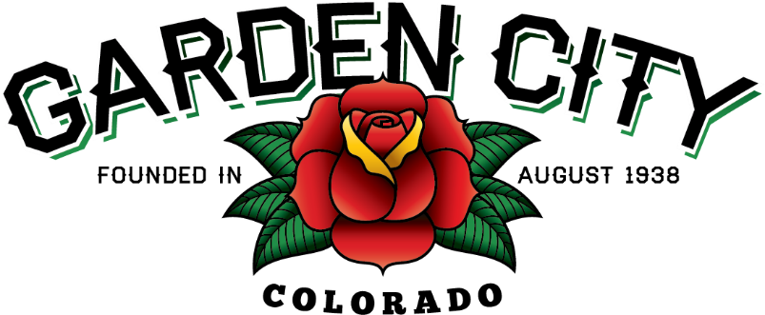

AGENDA
BOARD OF TRUSTEES
REGULAR MEETING 5:30 PM April 20, 2021

The Board will consider and may act on the following items:
- Call To Order
- Roll Call
- Consent Agenda
  - Approve Minutes From April 6, 2021 Meeting
  - Approve Treasurer’s Report For March
  - Approve Paid Bills
  - Approve Bills To Be Paid
  - Approve Tyler’s Invoice For $10,000 For InCode Court Implementation
  - Approve Xcel Invoice For $2,760.69 For Streetlight Maintenance
  - Approve Turn Key Invoice For $15,208.18 For Community Center Work
- Public Not On The Agenda Invited To Be Heard
- Consider Alley Repair
- Consider Bootleggin’ Days Suggestions
  - Clarence Krieger Memorial Car Show For Bootleggin’ Days
- Consider Additional Community Center Construction Estimates
  - Paint and Trim Estimates
  - French Drain Estimate
- Approve Revocable Permit For MAD Holdiings’ New Building At 2760 8th Avenue
- Consider Disposal Of Unused Assets
- Staff Reports
  - Town Administrator’s
  - Police Chief’s Report
  - Plant Manager’s Report
  - Attorney’s Report
- Other Board Issues
- Announcements
  - Spring Cleanup Days are April 30 – May 2
- Adjourn

