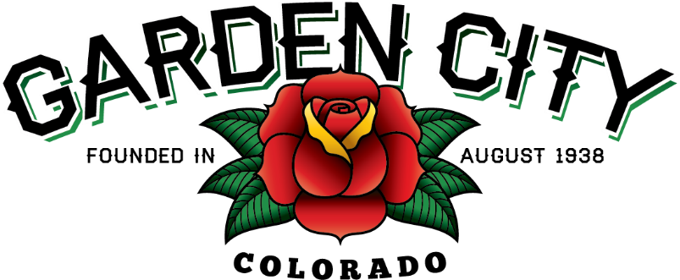

AGENDA
BOARD OF TRUSTEES
REGULAR MEETING 5:30 PM May 18, 2021

The Board will consider and may act on the following items:
- Call To Order
- Roll Call
- Consent Agenda
  - Approve Minutes From May 4, 2021 Meeting
  - Approve Treasurer’s Report For April
  - Approve Paid Bills
  - Approve Bills To Be Paid
  - Approve Journal Entries
  - Approve Fuzion Invoice For Cleanup Days In The Amount Of $3,010.00
- Public Not On The Agenda Invited To Be Heard
- Marijuana Licensing Issues
  - Nature’s Herbs And Wellness Center, LLC Medical Marijuana Store License ML-522-21 Renewal
  - Nature’s Herbs And Wellness Center, LLC Medical Marijuana Cultivation Facility License MMCF-52 Renewal
  - Nature’s Kitchen, LLC Medical Marijuana Products Manufacturer License MMPM-522-20 Renewal
- Age-Friendly Community Designation Presentation
- Consider Town Investment In Upstate Colorado Economic Development
- Approve Use Of Premises For Special Event Letters For National Night Out And Bootleggin’ Days
- Approve J2 Contracting Company Contract For 2021 Street Project
- Approve EFT Payments For MetLife Insurance
- Staff Reports
  - Town Administrator’s
  - Police Chief’s Report
  - Plant Manager’s Report
  - Attorney’s Report
- Other Board Issues
- Announcements
  - Bike Night is rescheduled for May 24th
- Adjourn

