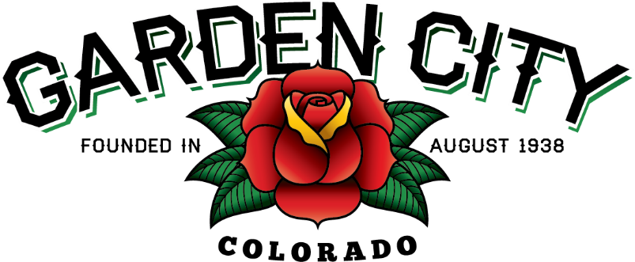

AGENDA
BOARD OF TRUSTEES
REGULAR MEETING 5:30 PM March 16, 2021

The Board will consider and may act on the following items:
- Call To Order
- Roll Call
- Consent Agenda
  - Approve Minutes From March 2, 2021 Meeting
  - Approve Treasurer’s Report For February
  - Approve Paid Bills
  - Approve Bills To Be Paid
  - Approve Journal Entries
  - Approve Turnkey Builders Invoice For Upgrades To Community Center In The Amount Of $25,795.92
- Public Not On The Agenda Invited To Be Heard
- Marijuana Licensing Issues
  - Report Of Changes For Modification Of Premises Application For Cannabis Cares Wellness Center, 2515 7th Avenue
- Consider Town Attorney Applications
- Approve 2021 Mosquito Control Services From Vector Disease Control
- Street Rehab Project Question
- Staff Reports
  - Police Chief’s Report
- Other Board Issues
- Announcements
  - Town Attorney Interviews on March 23rd, 2021 at 5:30 P.M.
  - The Easter Egg Hunt is scheduled for April 3, 2021 from 10:00 A.M. until Noon outdoors at the Community Center.
- Adjourn

