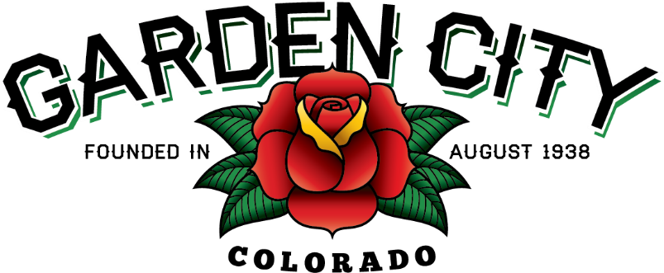

AGENDA
BOARD OF TRUSTEES
REGULAR MEETING 5:30 PM April 6, 2021

The Board will consider and may act on the following items:
- Call To Order
- Roll Call
- Consent Agenda
  - Approve Minutes From March 16, 2021 Regular Meeting
  - Approve Minutes From March 23, 2021 Special Meeting
  - Approve Updated Treasurer’s Report For February, 2021
  - Approve Paid Bills
  - Approve Bills To Be Paid
  - Approve Shiner Enterprises $8,000.00 Invoice For Snowplowing
  - Approve Tyler Technologies $3,727.50 Invoice For Software
- Public Not On The Agenda Invited To Be Heard
- Liquor Licensing Issues
  - El Rodeo Night Club LLC dba El Rodeo Tavern With Live Entertainment Liquor License Renewal
- Consider Easement For Sidewalk At 2760 8TH Avenue
- Consider Sidewalk On South Side Of 27th Street Road
- Town Attorney
  - Approve Contract For Town Attorney
  - Consider Appointment Of Town Attorney
  - Adopt Resolution 08-2021 A Resolution Appointing James Godbold Of Otis And Bedingfield, LLC As Garden City Town Attorney
- Greeley Planning Reviews
  - Project CU2020-0002 – Community Development Code Update
  - Project CU2021-0001 – Household Occupancy Standards
- Consider Bootleggin’ Days
- Staff Reports
  - Town Administrator’s Report
  - Police Chief’s Report
  - Plant Manager’s Report
- Other Board Issues
- Announcements
  - Bonnie’s last day will be April 8, 2021
  - Workshop for Arts Initiative on April 13, 2021 at 5:30 p.m.
  - Spring Cleanup Days are April 30 – May 2
- Adjourn

