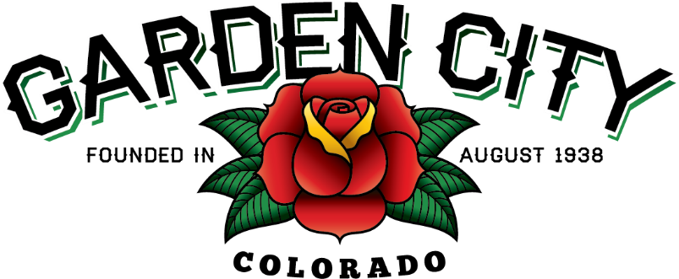

AGENDA
BOARD OF TRUSTEES
REGULAR MEETING
5:30 PM March 1, 2022

The Board will consider and may act on the following items:
- Call To Order
- Roll Call
- Consent Agenda
  - Approve Minutes From February 15, 2022 Regular Meeting
  - Approve January 2022 Treasurer’s Report
  - Approve Paid Bills
  - Approve Bills To Be Paid
  - Approve Invoice for 2022 City of Greeley 8th Avenue Street Maintenance in the amount of $1,175.00
- Public not the agenda
- Marijuana Licensing Issues
  - LivWell l LLC Marijuana Facility Permit RL-2647-22 Renewal at 2647 8th Ave Unit B
- Consider Attendance at CML Conference in Breckinridge on June 21-24, 2022
- Approve CIRSA training on Thursday April 28, 2022 at 5:30 PM for Elected Officials
- Consider Spring, Summer, and Fall Community Clean Up Days Including Dates
- Approve Dates for 2022 Bootleggin’ Days
- Consider Removal of Island on 27th Street Between 8th and 9th Avenue
- Staff Reports
  - Town Administrator’s Report
  - Police Chief’s Report
  - Public Works Director’s Report
  - Town Attorney’s Report
- Other Board Issues
- Announcements
  - Americanism Day is Sunday February 27, 2022 at 12:30 PM at VFW Post 2121
  - The First FCPA Campaign Finance Form is Due March 15, 2022
- Adjourn

