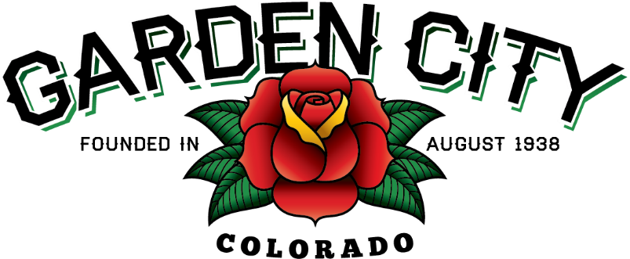

AGENDA
BOARD OF TRUSTEES
REGULAR MEETING 5:30 PM March 15, 2022

The Board will consider and may act on the following items:
- Call To Order
- Roll Call
- Consent Agenda
  - Approve Minutes From March 1, 2022 Regular Meeting
  - Approve Paid Bills
  - Approve Bills To Be Paid
  - Approve Invoice from Naranjo for sediment removal in the amount of $3,200.00
- Public not on the agenda
- Swearing in Reserve Police Officer Ashley Perez
- Consider Letter of Engagement from Anderson and Whitney for 2021 Audit
- Consider Service Contract for Town Vehicles
- Consider Shop Building Plans
- Consider Resolution 09-2022 A Resolution Approving Quitclaim Deeds Conveying Property To Lot 1 And Lot 2 Of Garden City 2nd Town Hall Subdivision.
- Ordinance 01-2022 An Ordinance Amending Chapter 6, Article 2 of the Town of Garden City Municipal Code to Authorize the Local Licensing Authority to Issue Festival Permits and to Update Statutory References in the Chapter.
- Consider Installation of Compact Car Parking Signs on 8th Ave
- First reading of Ordinance 02-2022 An Ordinance Granting A Franchise By The Town of Garden City, County Of Weld, Colorado To Atmos Energy Corporation, Its Successors And Assign, The Right To Furnish, Sell And Distribute Gas To The Town And To All Persons, Businesses And Industries Within The Town And The Right To Operate And Extend Into, Within And Through Said Town All Facilities Reasonably Necessary To Furnish, Sell And Distribute Gas To The Town And To All Persons, Businesses And Industries Within The Town And In The Territory Adjacent Streets And Other Public Places As May Be Necessary, And Fixing The Terms And Conditions Thereof.
- Consider Donation of $250.00 to the Salvation Army
- Discuss Suspensions of Orozco Private Security License and Orozco Security Services’ License- May be Executive Session
- Staff Reports
  - Town Administrator’s Report
  - Police Chief’s Report
  - Public Works Director’s Report
  - Town Attorney’s Report
- Other Board Issues
- Announcements
  - First FCPA report due March 15, 2022
  - The next Town Board meeting will be April 4, 2022
  - Election Day is April 5, 2022
  - The Town of Garden City will host its annual Easter Egg Hunt on April 9, 2022 at 10:00 a.m. at the Town Hall.
- Adjourn

