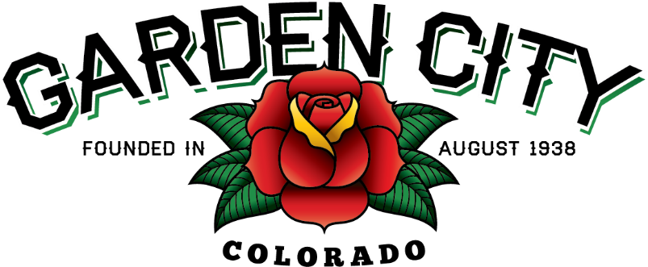

AGENDA
BOARD OF TRUSTEES
REGULAR MEETING 5:30 PM May 4, 2021

The Board will consider and may act on the following items:
- Call To Order
- Roll Call
- Consent Agenda
  - Approve Minutes From April 20, 2021 Regular Meeting
  - Approve Paid Bills
  - Approve Bills To Be Paid
  - Approve Journal Entry
  - Approve Payment to Rainbow Custom Finishes In The Amount Of $3,607.50
- Public Not On The Agenda Invited To Be Heard
- Consider Bootleggin’ Days
- Approve Replacing Bench In Front Of Tattoo Shop
- Staff Reports
  - Town Administrator’s Report
  - Police Chief’s Report
  - Plant Manager’s Report
  - Attorney’s Report
- Other Board Issues
- Announcements
  - Bike Night is Monday, May 10th, starting at 5:00 p.m.
- Adjourn

