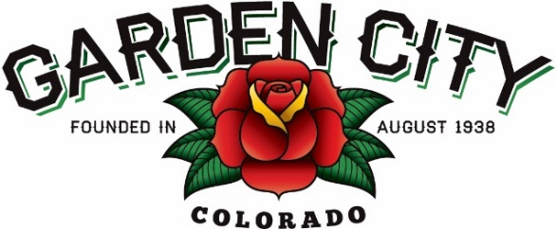
Board of Trustees Regular Meeting Agenda
June 17, 2024 at 5:30 PM
Town Hall - 621 27th Street Road, Garden City, CO 80631
The Board will consider and may act on the following items:
1. Call to Order
2. Roll Call
3. Consent Agenda
a. Approve Minutes from June 4, 2024 Regular Meeting
b. Approve Treasurer’s Report from May, 2024
c. Approve Bills Paid
d. Approve Bills to be Paid
e. Approve J&T Consulting LLC invoice in the amount of $32,195.85
4. Public Not on the Agenda Invited to be Heard
5. Grants
a. Consider BNK REI LLC Pavement Grant Application
6. Public Hearing regarding Ordinance 05-2024 An Ordinance Of The Town Of Garden City, Colorado Adopting By Reference Certain Sections Of The "Greeley Municipal Code"
7. Ordinances
a. Adopt Ordinance 05-2024 An Ordinance Of The Town Of Garden City, Colorado Adopting By Reference Certain Sections Of The "Greeley Municipal Code"
8. 2626 8th Avenue
a. Reconsider denial of 2626 8th Avenue use by Animal Health International
b. Consider timeline to vacate 2626 8th Avenue, if denied in previous item
9. Approve PTO day for Cheryl Campbell on June 26, 2024
10. John Rotherham from Nature's Herbs and Wellness Center and High Plains Strainz regarding Retail Marijuana Hospitality issue
a. John Rotherham from Nature's Herbs and Wellness Center and High Plains Strainz regarding Retail Marijuana Hospitality issue
11. Update on Builder's FirstSource
12. Staff Reports
a. Town Administrator
b. Police Chief
c. Public Works Director
d. Town Attorney
13. Other Board Issues
14. Announcements
- The CML Annual Conference is Tuesday June 18th through Friday June 21st in Loveland
- On June 26th, there is a 10am site visit to view drainage issue at 500 27th Street
15. Adjourn

