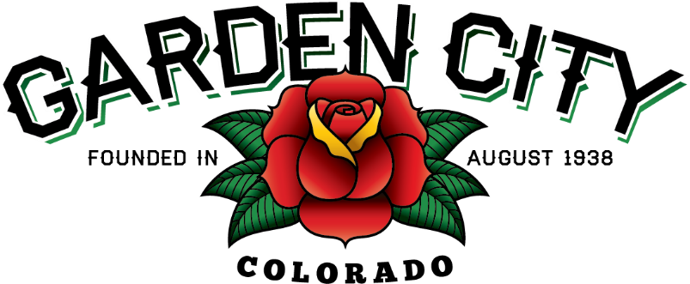

AGENDA
BOARD OF TRUSTEES
REGULAR MEETING
5:30 PM February 15, 2022

The Board will consider and may act on the following items:
- Call To Order
- Roll Call
- Consent Agenda
  - Approve Minutes From February 1, 2022 Regular Meeting
  - Approve Minutes From February 8, 2022 Special Meeting
  - Approve Paid Bills
  - Approve Bills To Be Paid
  - Approve Invoice for J&T Consulting in the amount of $12,104.70
- Public not the agenda
- Adopt Resolution 08-2022 A Resolution Granting A Use By Special Review
- Approve Order Approving USR 2022-01
- Consider Amount to Be Paid by the Town for Employees to Globe Insurance
- Consider Service Contract for Town Vehicles
- Consider Attending the Americanism Banquet at the VFW on February 27, 2022
- Consider Increase of stipend for the judge for 2022
- Consider Placement and Costs for the Compact Car Parking Signs on 8th Ave
- Approve Vehicle Policies
  - Town Vehicle Policy
  - PD Vehicle Policy
- Staff Reports
  - Town Administrator’s Report
  - Police Chief’s Report
  - Public Works Director’s Report
  - Town Attorney’s Report
- Other Board Issues
- Announcements
  - Town Hall will be closed on February 21, 2022 in observance of President’s Day
  - Americanism Day is Sunday February 27, 2022 at 12:30 p.m. at the VFW
- Adjourn

