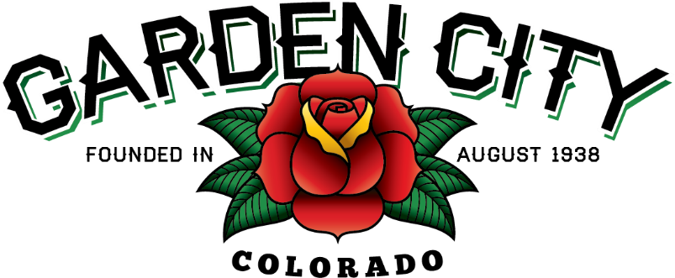

AGENDA
BOARD OF TRUSTEES
REGULAR MEETING 5:30 PM April 19, 2022

The Board will consider and may act on the following items:
- Call To Order
- Roll Call
- Consent Agenda
  - Approve Minutes from April 4, 2022 Regular Meeting
  - Approve Minutes from April 12, 2022 Special Meeting
  - Approve March 2022 Treasurer’s Report
  - Approve Paid Bills
  - Approve Bills To Be Paid
- Public Not on the Agenda
- Public Hearing Regarding USR 2022-02
- Consider Land Use Application USR 2022-02
- Marijuana Licensing Issues
  - Modification of Premises Application – Nature’s Herbs & Wellness 522 27th Street
- Commercial Revitalization Grant Application – American Steel 2733 8th Avenue
- Commercial Revitalization Grant Application – Greeley Hat Works 2613 8th Avenue
- Tree Grant Application – Lowell Ferguson 2704 7th Avenue
- Approve Contract for 2022 Mosquito Spraying
- First reading of Ordinance 02-2022 An Ordinance Granting A Franchise By The Town of Garden City, County Of Weld, Colorado To Atmos Energy Corporation, Its Successors And Assign, The Right To Furnish, Sell And Distribute Gas To The Town And To All Persons, Businesses And Industries Within The Town And The Right To Operate And Extend Into, Within And Through Said Town All Facilities Reasonably Necessary To Furnish, Sell And Distribute Gas To The Town And To All Persons, Businesses And Industries Within The Town And In The Territory Adjacent Streets And Other Public Places As May Be Necessary, And Fixing The Terms And Conditions Thereof.
- Consider Weld County Referral #LLA22-0014
- Approve J & T Proposal for 2022 Street Rehabilitation Construction Management in the amount of $38,850.00
- Appoint Officers for the 2022-2024 Term
- Cheryl Campbell – Town Administrator/Clerk
- Adopt Resolution No. 10-2022 A Resolution Appointing Cheryl Campbell as Town Administrator and Town Clerk Pursuant to C.R.S. 31-401-304
- James Godbold – Town Attorney
- Michael Stewart – Municipal Judge
- Consider Removal of Bollards on the West Side of 8th Avenue between 25th and 26th Streets
- Consider Xeriscaping the Grass Strip on the South Side of Town Hall Parking Lot
- Consider Moving First Farm CD to Stifel Investments
- Approve Release of Obsolete Tasers to Nunn Police Department

- Staff Reports
  - Town Administrator’s Report
  - Police Chief’s Report
  - Public Works Director’s Report
  - Town Attorney’s Report
- Consider Orozco Security Agency LLC Licensing Issues – May be an Executive Session
- Other Board Issues
- Announcements
  - CIRSA Elected Officials Training is Thursday April 28, 2022 at 5:30 PM
  - Wine and Paint is Saturday April 30, 2022
  - FCPA Final Reports are due May 5, 2022
- Adjourn

