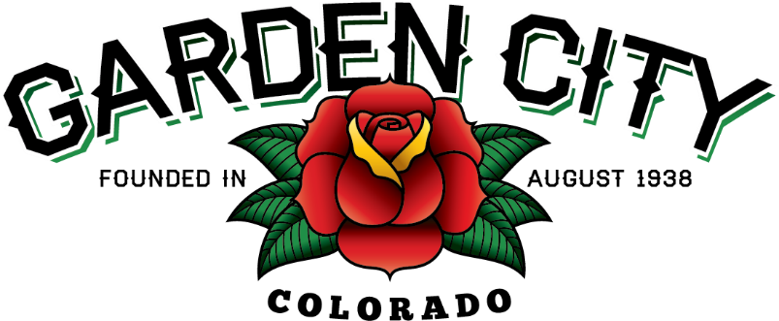

AGENDA
BOARD OF TRUSTEES
REGULAR MEETING 5:30 PM June 15, 2021

The Board will consider and may act on the following items:
- Call To Order
- Roll Call
- Consent Agenda
  - Approve Minutes from June 1, 2021 Meeting
  - Approve Treasurer’s Report For May, 2021
  - Approve Paid Bills
  - Approve Bills To Be Paid
  - Approve Journal Entries
  - Approve Payment Of J2 Invoice for $183,135.51
  - Approve Payment Of J & C Consulting Invoice For $19,333.35
  - Approve Payment Of Two Turnkey Invoices For A Total Of $58,546.54
- Public Not On The Agenda Invited To Be Heard
- Consider Dispensary Hours
- Marijuana Licensing Issues
  - Cannabis Care Wellness Centers LLC DBA Smokey’s Medical Center License Renewal ML-2515-21
b. Green Medicals Wellness Center #5 LLC DBA Smokey’s Medical Marijuana Cultivation Facility License Renewal MMCF-2515-21
- Consider Rescheduling August 3, 2021 Board Meeting
- Approve Letter To The Secretary Of The U.S. Department of Transportation
- Approve CML Conference Attendance For Trustees, Staff, And Town Attorney
- Consider Regional Air Quality Council Donation
- Approve BDO USA LLP Letter Of Engagement For 2020 Audit
- Staff Reports
  - Town Administrator’s Report
  - Police Chief’s Report
  - Plant Manager’s Report
  - Attorney’s Report
- Other Board Issues
- Announcements
  - Movie Night is on June 17th at the Community Center starting at dusk
  - Abby will be on vacation from July 2 - 9, 2021
- Adjourn

