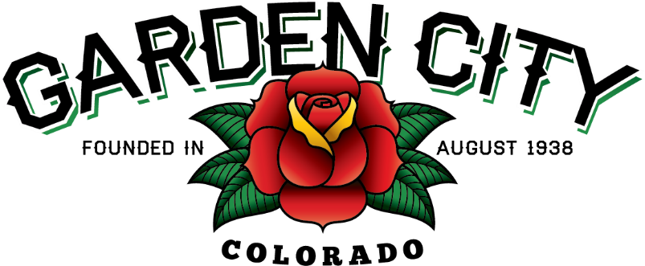

AGENDA
BOARD OF TRUSTEES
SPECIAL MEETING 5:30 PM February 8, 2022

The Board will consider and may act on the following items:
- Call To Order
- Roll Call
- Approve December 2021 Treasurer’s Report
- Consider Conditions Regarding Land Use Application USR 2022-01
- Other Board Issues
- Announcements
  - Work Session for Town Vehicle Policies will be on February 8, 2022 immediately following the Special Meeting. Dinner will be provided
- Adjourn

