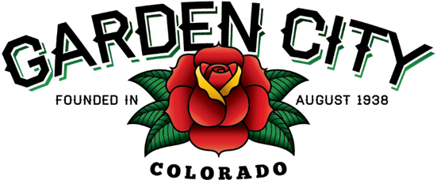

AGENDA
BOARD OF TRUSTEES
REGULAR MEEETING 5:30 PM June 1, 2021

The Board will consider and may act on the following items:
- Call To Order
- Roll Call
- Consent Agenda
  - Approve Minutes From May 18, 2021 Meeting
  - Approve Paid Bills
  - Approve Bills To Be Paid
- Public Not On The Agenda Invited To Be Heard
- Approve Collection Services agreement
- Appoint CML Voting Delegate
- Consider Holiday Parties
a. Christmas Dinner
b. Holiday Resident Luncheon
- Consider Town Staff Salaries
- Consider Budget Items for 2022
- Staff Reports
  - Town Administrator’s
  - Police Chief’s Report
  - Plant Manager’s Report
  - Attorney’s Report
- Other Board Issues
- Announcements
- Movie night is June 17, 2021. Lilo and Stitch will be showing at dusk.
- Adjourn

