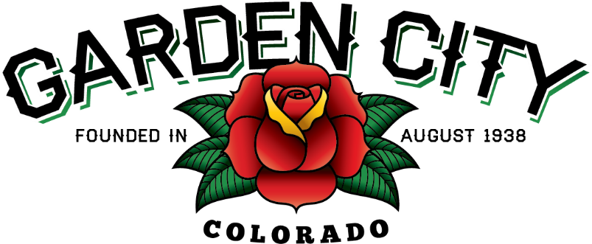

AGENDA
BOARD OF TRUSTEES
REGULAR MEETING 5:30 PM January 18, 2022

The Board will consider and may act on the following items:
- Call To Order
- Roll Call
- Consent Agenda
  - Approve Minutes From January 4, 2022 Meeting
  - Approve Paid Bills
  - Approve Bills To Be Paid
  - Approve CIRSA Property/Casualty 2022 Premium Invoice in the amount of $24,916.64
  - Approve CIRSA Workers’ Compensation 2022 Premium Invoice in the amount of $15,067.00
  - Approve CIRSA CSWAMP/Occupational AD&D/VAMP/Detainee Medical 2022 Premium Invoice in the amount of $1,303.02
  - Approve Weld County Regional Communications 2022 Dispatch Invoice in the amount of $19,281.00
- Public not the Agenda
- Liquor Licensing Issues
  - Wing Shack Enterprises Inc Permit Application and Report of Changes for new registered manager
  - Wing Shack Enterprises Inc dba 8th Ave Wing Shack Hotel/Restaurant Liquor License Renewal
- Consider 2022 Town Events
- Consider policies regarding vehicles
- Staff Reports
  - Town Administrator’s Report
  - Police Chief’s Report
  - Public Works Director
  - Town Attorney’s Report
- Other Board Issues
- Announcements
  - Winter BonFire will be held January 22, 2022 from 5-9 p.m.

- Adjourn

